Given a linked list, determine if it has a cycle in it.

To represent a cycle in the given linked list, we use an integer pos which represents the position (0-indexed) in the linked list where tail connects to. If pos is -1, then there is no cycle in the linked list.

**Example 1:**

**Input:** head = [3,2,0,-4], pos = 1

**Output:** true

**Explanation:** There is a cycle in the linked list, where tail connects to the second node.

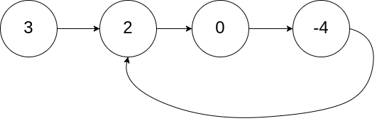

**Example 2:**

**Input:** head = [1,2], pos = 0

**Output:** true

**Explanation:** There is a cycle in the linked list, where tail connects to the first node.

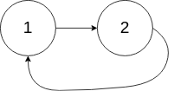

**Example 3:**

**Input:** head = [1], pos = -1

**Output:** false

**Explanation:** There is no cycle in the linked list.



**Follow up:**

Can you solve it using *O(1)* (i.e. constant) memory?